**Supplemental table 1. Standardization and Quality Control Parameters for Transcriptomics Technologies.** “*” denotes technologies approved by TISAC for interrogating patient biopsies (July 2020).

|  |  |  |  |  |  |
| --- | --- | --- | --- | --- | --- |
| **Category/Site** | **UCSD-WU** | **PREMIERE** | **UCSF** | **IU-OSU** | **Standardized QC** |
| **Technology** | **snRNA-seq\*** | **scRNA-seq\*** | **mDroscRNA-seq** | **LMD mRNA* subsegmental**  **and bulk miRNA** | **All RNA OMIC** |
| **Sample Preservation/Storage/Processing/ Transport Parameters** | * Fresh frozen OCT * -80 °C * Cryosection (2-20mm3), RNAlater * Nuclear prep (>10K) * Dry ice | * Fresh frozen Cryostor * -80 °C * Dissociation (Liberase) * Dry ice | * Fresh frozen Cryostor * -80 °C * Dissociation (Liberase) * Dry ice | * Fresh frozen OCT * -80 °C * mRNA: Cryosection, dissect subsegments < 2 h, >500Ksqm * miRNA: Cryosection 20-60 µm * Dry ice | * Pre-analytical * Tissue procurement * Tissue processing (preservation, path assessment) * Shipping (dry ice) * Supplies * Storage (-80 °C) |
| **Assay (RNA QC, library preps, Instrument, Sequencing)** | * Lib size (200-1000bp) * Bioanalyzer 2100 * 10X Chromium * Illumina * Paired end (30x100) | * Lib size (200-1000bp) * Bioanalyzer 2100 * Illumina * 10X Chromium * Paired end (30x100) | * Lib size (200-1000bp) * Bioanalyzer 2100 * 10X Chromium * Illumina * Paired end (30x100) | * DV200 > 25% * Lib size (200-1000bp) * Bioanalyzer 2100 * RNA ref std (Stratagene) * Illumina * Paired end (30x100) | * RNA quality (DV200>25%; RIN for bulk > 6.0) * Library size (200-1000bp) * RNA ref std for bulk (Stratagene) * Instrument * Sequencing platforms |
| **Analytics (QC filters, artifacts, softwares, thresholds)** | * >400<7500 genes/nucleus * Seurat V3 or Pagoda 2 * UMAP cluster * Reference markers for annotations * >30 cell/integrated clusters * >100 QC nuclei/sample * GRCH38 | * >500<5000 genes/cell * MT<20% or <50% (Seurat V2/V3) * UMAP cluster * Reference markers for annotations * >30 cell/integrated clusters * >100 QC cell/sample * GRCH38 | * >500<5000 genes/cell * MT <50% (Seurat V3) * UMAP cluster * Reference markers for annotations * >30 cell/integrated clusters * GRCH38 * >100 QC cell/sample * GRCH38 | * Read count > 10 over 50% of samples for at least 1 subsegment * >1 million reads/sample * Edge R * Reference markers for annotations * GRCH38 | * >400/500<5000 genes/cell (sn/sc) * Seurat V3 * Reference genome GRCH38 * UMAP cluster * Reference markers for annotations * >30 cell/integrated clusters * >50/100 (sn/sc) datasets per sample |
| **Data deposition** | * Fastq, bam * Count matrix R Objects | * Fastq, bam * Count matrix R Objects | * Fastq, bam * Count matrix R Objects | * Fastq, bam * Count matrix R Objects, csv, txt | * Fastq, bam * Count matrix R Objects * csv, txt |

**Supplemental table 2. Standardization and Quality Control Parameters for Proteomics and Metabolomics Technologies.** “*” denotes technologies approved by TISAC for interrogating patient biopsies (July 2020).

|  |  |  |  |  |
| --- | --- | --- | --- | --- |
| **Category/Site** | **UCSF** | **IU-OSU** | **UTHSA-PNNL-EMBL** | **Standardized QC** |
| **Technologies** | **nscProteomics** | **LMD regional proteomics\*** | **Spatial Metabolomics\*** | **All Proteomics and Metabolomics** |
| **Sample Preservation/Storage/Processing/ Transport Parameters** | * Fresh frozen OCT * -80 °C * Cryosections * Dry ice | * Fresh frozen OCT * -80 °C * Cryosections * Dry ice | * LN2 snap frozen * -80 °C * Cryosection * Dry ice | * Pre-analytical * Tissue procurement * Tissue processing (preservation, path assessment) * Shipping (dry ice) * Supplies * Storage (-80 °C) |
| **Assay** | * adjacent sections > 10 cells per region * Orbitrap Fusion (< 3 ppm calibration accuracy) * Peptide standards | * 10,000-20,000 glomerular or tubular cells * Orbitrap Fusion (< 3 ppm calibration accuracy) * Peptide standards | * Entire tissue section, bulk analysis on remaining * Orbitrap QE and FTICR-MS (< 3 ppm calibration accuracy) * Commercial tune mix | * Tissue sectioning * Cell /region isolation * Orbitrap Fusion (proteomics) * Peptide standards (proteomics) |
| **Analytics** | * >2000 proteins per 10 cell prep * > 6aa * <4600Da peptide mass * Missed cleavage for peptides = 2 * < 1% FDR * > 97% correlation for peptides in replicates * Reference markers for annotations | * > 3000 proteins identified * < 1% FDR * Reference markers for annotations | * >100 annotated metabolites per section (<20% FDR) * Detection of standard metabolites * Detection of location specific metabolites * Histology correlation | * > 2000/3000 proteins (nsc/LMD) * < 1% FDR (nsc, LMD) * Standard metabolites and renal metabolites |
| **Data deposition (file types)** | * .raw, .csv | * .raw, .csv | * MALDI-MSI: .d/.mis, .xml, .imzML, .ibd, raw, csv * LC-MS/MS: .raw, .mzML | * raw, csv (proteomics) * raw (LC-MS/MS) * d/mis, imzML, ibd, raw, csv (MALDI-MSI) |

**Supplemental table 3: Label-based imaging QC.** “*” denotes technologies approved by TISAC for interrogating patient biopsies (Jan. 2020).

|  |  |  |  |  |  |
| --- | --- | --- | --- | --- | --- |
|  | **IU-OSU** | **UCSD-WU** | **UM-Broad-Princeton** | **UCSF** | |
| **Technology** | 3D Tissue Cytometry* | DART-FISH2 | ISH | mIFISH | CODEX |
| **Probe Targets Per Section** | 8 Immunofluor targets | >50 mRNAs | 3-10 mRNA | 20 mRNA & proteins | 30 proteins |
| **2D or 3D Imaging?** | 3D | 3D​ | 2D | 2D | |
| **Spatial Resolution** | 0.5-1 μm | 1 μm | single cell | 1μm/single cell | |
| **Cell type and structure mapping** | Validated antibodies and fluorescent small molecules known to bind specific cell types | nuclear stain, lectin labeling for PT or CD, autofluorescence | cell specific RNA and histological stain in sequential plane | Anchor (structural) and immune cell  and interstitial compartment mapping at single cell resolution with direct H&E correlation | |
| **Area/Volume of Imaging Region** | Entire biopsy length (1-1.5cm) x 50μm thickness | 10-20 micron sections of 1 mm2 | Entire biopsy length (1-1.5cm) x 5 μm thickness | Entire biopsy (20-25 mm2) | |
| **Dimensions of Image Voxels** | 0.5 x 1μm x 1μm | 0.15 x 0.15 x 0.3 μm | N.A. | N.A. | |
| **Amount of Tissue** | Minimum: One 50 um thick section (imaging/staining) | 10 x 10 μm thick sections | 5 μm thick section for each probe target | One 3μm-thick FFPE section for each 21-plex mIFISH stain. Two 3μm-thick FFPE sections for a positive/negative ISH control. | One 5μm-thick OCT section for each 32-plex CODEX stain |
| **Pre-imaging QC** | -Primary Ab validation  -Pre-staining with secondary antibodies as a negative control  -AF/SHG (tissue quality)  -16 channel pre-stain imaging | -Validation of generated probes  -Maintenance of fluorescent imaging system | In development | -Instrument: Auto-calibrated with each use  -Tissue: H&E to assess tissue integrity  -Antibody validation:  IPOX/IIF/orthogonal | -Instrument: standardized imaging of IF calibration slides at regular intervals  -Tissue: H&E-stained sections to assess tissue integrity/freezing artifacts  -Oligo-labeling: comparison of the staining across CODEX, indirect IF, and IPOX platforms |
| **Acquisition QC** | -Reuse acquisition  settings  -Point Spread Function  -Signal to noise ratio | -Signal to Noise Ratio  -Number of rolonies decoded  -Number of genes decoded | -Negative control: DapB  -Positive control:  housekeeping genes | -On-slide tissue microarray controls  -Built in software function to set exposure times  -New antibody lots compared  to  "gold standard" --epifluorescent images for batch consistency  -ISH: positive & negative control probes | -Labeling-detection: on-slide tissue microarray controls  -Imaging: saturation based on histogram  -Cell clustering by intensity gating: visual assessment of the raw image |
| **Analysis QC** | Unmixing (labeled beads at known ratios)  Segmentation quality (F1 scores) | -Misclassification rate (accuracy of barcode decoding)  -Number of rolonies per cell | In development | Visual inspection of analyzed images: segmentation & analyte detection accuracy | Cell clustering by intensity gating & visual assessment of the raw image |
| **Imaging and Analysis Throughput** | 2-3 samples per week | 1 section per week | In development | 8 sections/week (mIFISH) | 2-3 sections/week (CODEX)​ |

**Supplementary table 4. Harmonized imaging parameters and metadata to be recorded across TIS sites.**

|  |  |  |  |
| --- | --- | --- | --- |
|  | | **Feature** | **Value (ex. IU/OSU)** |
| **Sample characteristics** | | Specimen ID | **18-142-04** |
| Derived specimen ID | **18-0007** |
| Data Lake Package ID | 9d401b61-55f2-4d8b-93f9-f473756d9cfc |
| Tissue thickness | 50 microns |
| Gross sample quality | Annotated macro image |
| Quantified sample quality | RNA quality (DV200 value) |
| Sample preparation - methods | MOP version number |
| Sample preparation - reagents | Vendor, catalog number, batch |
| Image sample preparation  - quality control | Reagent validation images |
| **Image data and collection** | **Raw target image data** | Technology | 3D multiple fluorescence |
| Number of targets | 8 |
| Target IDs | THP, F-actin, AQP1, CD3,CD68, SIGLEC8, MPO, DNA |
| Sample volume imaged | Entire area (e.g., 3 mm x 6 mm) x 50 microns depth |
| Voxel dimensions | 0.5 x 0.5 x 1 micron |
| Raw target image file format | 16 channel Leica .lif |
| Raw target image file size | 100 GB |
| Image acquisition metadata | Leica lif file |
| **Raw label-free image data** | Technology | Autofluorescence, SHG |
| Sample volume imaged | Entire area (e.g., 3 mm x 6 mm) x 50 microns depth |
| Voxel dimensions | 0.5 x 0.5 x 1 micron |
| Raw label-free image format | 2 channel Leica .lif |
| Raw label-free image file size | 10 GB |
| Image acquisition metadata | Leica lif file |
| **Image collection** | Image collection - methods | MOP version number |
| Image collection  - quality control | Image of standard beads (SNR) |
| Image of resolution standard beads (PSF) |
| **Image analysis** | | Image analysis methods | MOP version number |
| Image analysis software | VTEA 0.5.2 |
| Image processing record | VTEA log file |
| Image processing QC metrics | Spectral deconvolution of beads |
| **Results** | | Output, deconvolved target image data | 3D, 8-channel fluorescence image volume |
| Output target image file format | .tiff |
| Output target image file size | 50 GB |
| Output label-free image data | 3D, 2-channel autofluorescence/SHG image |
| Output label-free image format | .tiff |
| Output label-free image file size | 10 GB |
| Image visualization access | Online 3D rendering |
| Derived measurements | Total cell number. Numbers of PT, TAL, vascular endothelia, T-cell, macrophages, neutrophils, eosinophils |
| Measurement data files | Raw results |
| Supervised data analysis |
| Unsupervised data analysis |
| Data visualization access | VTEA |
| Image cross-mapping | PAS in adjacent section |
| Omics cross-mapping | RNA from LMD in next section |

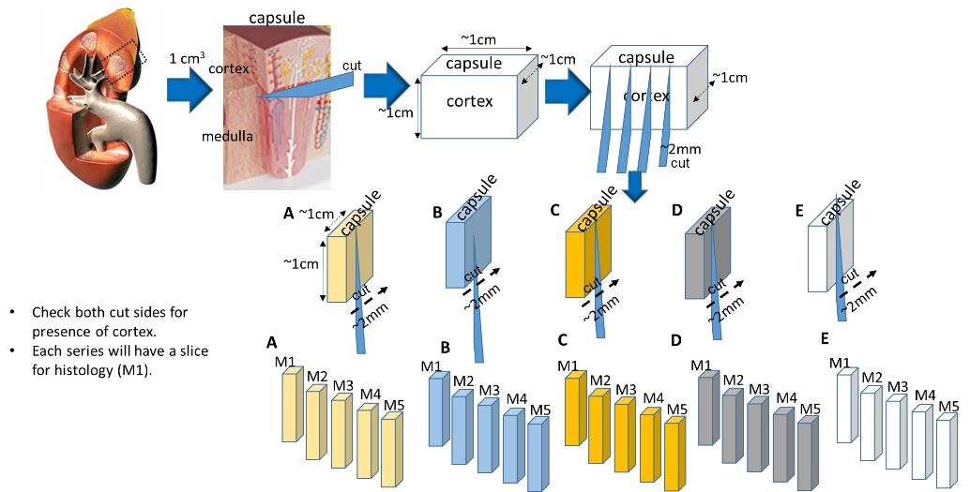**Supplementary figure 1**

**Supplemental Figure 1: Sectioning design for a same source tissue KPMP pilot**

**Supplementary figure 2**

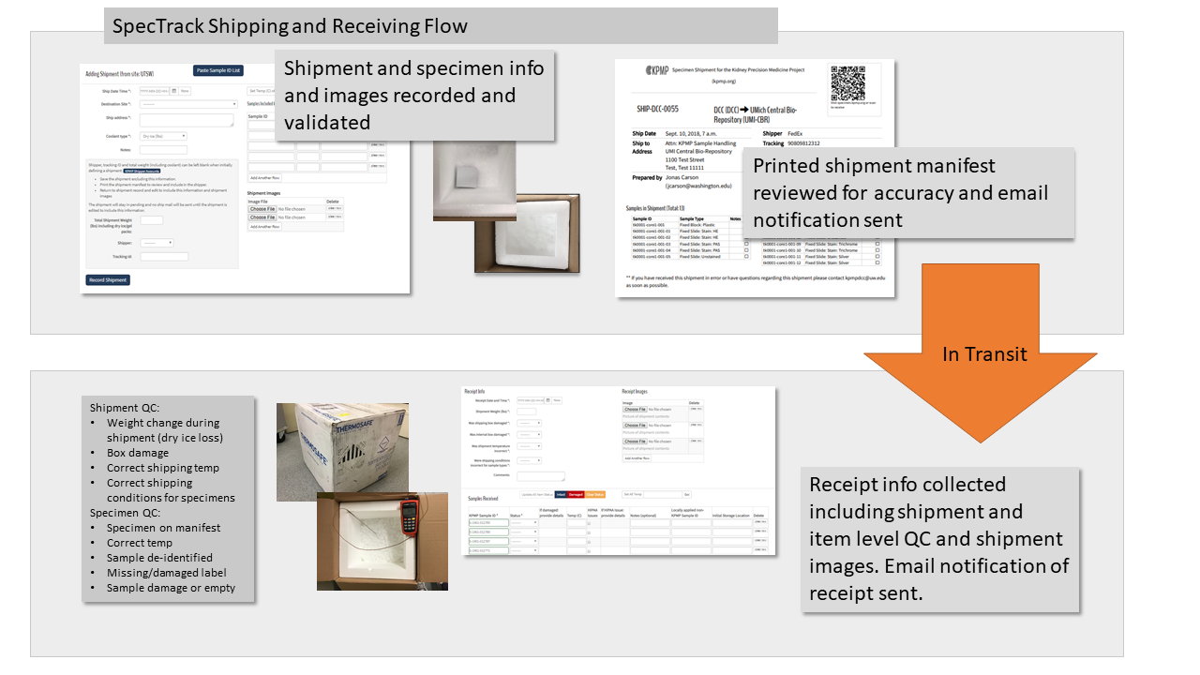

**Supplemental Figure 2: SpecTrack software and shipment workflow**. Spectrak is a customized software designed by the KPMP to track in real-time the tissue transfer and all quality control metrics associated with shipment and handling.

**Supplementary figure 3**

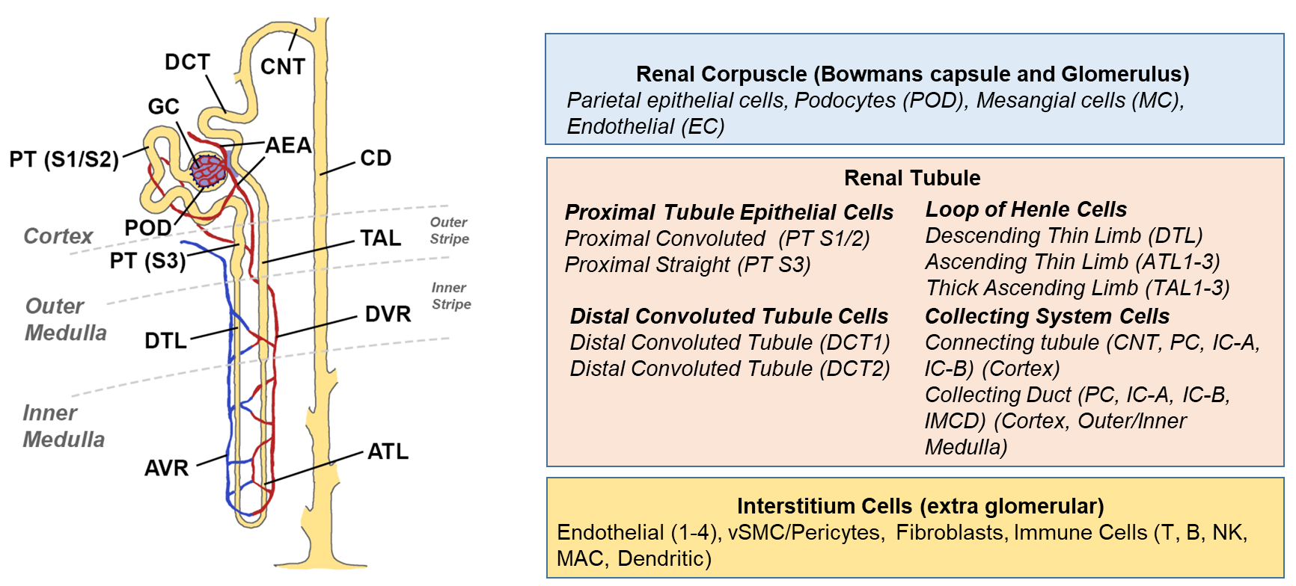

**Supplemental Figure 3: Kidney regions and cell types.** The nephron illustration is based on Kriz, W. & Bankir, L. A standard nomenclature for structures of the kidney. The Renal Commission of the International Union of Physiological Sciences(IUPS).Kidney Int.33,1–7 (1988). T, T lymphocyte; B, B lymphocyte; NK, natural killer cell; MAC, macrophage.